**ROAD ACCIDENT QUERY DOC**

**SQL/POWER BI.**

**ABOUT.**

This project focuses on analyzing road accidents using SQL and Power BI, leveraging key metrics such as accident date, severity, casualties, road surface conditions, road type, vehicle type, urban or rural area classification, and weather conditions. The goal is to gain insights into accident patterns, identify risk factors, and inform targeted safety interventions.

**PROBLEM STATEMENT**

**A.KPI's**

**1.PRIMARY KPI'S**

**-Total Casualties**

SELECT

SUM(Number_of_Casualties) as Number_of_Casualties

FROM Road_Accident_Data

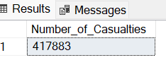

**-CY Casualties**

ALTER TABLE Road_Accident_Data

ADD Accident_Yr DATE

ALTER TABLE Road_Accident_Data

ALTER COLUMN Accident_Yr INT

UPDATE Road_Accident_Data

SET Accident_Yr = YEAR(Accident_Date)

--..NOW CY Casualties

SELECT

SUM(Number_of_Casualties) as CY_Number_of_Casualties

FROM Road_Accident_Data

WHERE Accident_Yr = 2022

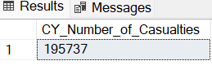

**-PY Casualties**

SELECT

SUM(Number_of_Casualties) as PY_Number_of_Casualties

FROM Road_Accident_Data

WHERE Accident_Yr = 2021

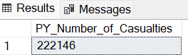

**-YoY Change**

SELECT

ROUND(

100 *(

CAST((SELECT SUM(Number_of_Casualties) FROM Road_Accident_Data WHERE Accident_Yr = 2022) AS FLOAT)-

CAST((SELECT SUM(Number_of_Casualties) FROM Road_Accident_Data WHERE Accident_Yr = 2021)AS FLOAT))/

CAST((SELECT SUM(Number_of_Casualties) FROM Road_Accident_Data WHERE Accident_Yr = 2021) AS FLOAT), 1) AS YoY_pct_change

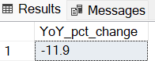

**-Fatal Casualties**

**-CY Fatal Casualties**

SELECT

SUM(Number_of_Casualties) as Fatal_Casualties

FROM Road_Accident_Data

WHERE Accident_Yr = 2022 and Accident_Severity = 'Fatal'

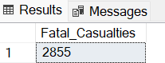

**-PY Fatal Casualties**

SELECT

SUM(Number_of_Casualties) as Fatal_Casualties

FROM Road_Accident_Data

WHERE Accident_Yr = 2021 and Accident_Severity = 'Fatal'

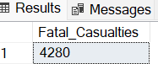

**-YoY pct change in Fatal Casualties**.

SELECT

ROUND(

100 *(

CAST((SELECT SUM(Number_of_Casualties) FROM Road_Accident_Data WHERE Accident_Yr = 2022 and Accident_Severity = 'Fatal') AS FLOAT)-

CAST((SELECT SUM(Number_of_Casualties) FROM Road_Accident_Data WHERE Accident_Yr = 2021 and Accident_Severity = 'Fatal') AS FLOAT))/

CAST((SELECT SUM(Number_of_Casualties) FROM Road_Accident_Data WHERE Accident_Yr = 2021 and Accident_Severity = 'Fatal') AS FLOAT), 1) YoY_pct_change

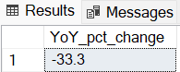

**-CY Slight Casualties**

SELECT

SUM(Number_of_Casualties) as CY_Slight_Casualties

FROM Road_Accident_Data

WHERE Accident_Yr = 2022 and Accident_Severity = 'Slight'

**-PY Slight Casualties**

SELECT

SUM(Number_of_Casualties) as PY_Slight_Casualties

FROM Road_Accident_Data

WHERE Accident_Yr = 2021 and Accident_Severity = 'Slight'

**-YoY pct change in Slight Casualties.**

SELECT

ROUND(

100 *(

CAST((SELECT SUM(Number_of_Casualties) FROM Road_Accident_Data WHERE Accident_Yr = 2022 and Accident_Severity = 'Slight') AS FLOAT)-

CAST((SELECT SUM(Number_of_Casualties) FROM Road_Accident_Data WHERE Accident_Yr = 2021 and Accident_Severity = 'Slight') AS FLOAT))/

CAST((SELECT SUM(Number_of_Casualties) FROM Road_Accident_Data WHERE Accident_Yr = 2021 and Accident_Severity = 'Slight') AS FLOAT), 1) YoY_pct_change

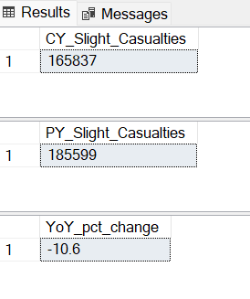

**-CY Serious Casualties**

SELECT

SUM(Number_of_Casualties) as CY_Serious_Casualties

FROM Road_Accident_Data

WHERE Accident_Yr = 2022 and Accident_Severity = 'Serious'

**-PY Serious Casualties**

SELECT

SUM(Number_of_Casualties) as PY_Serious_Casualties

FROM Road_Accident_Data

WHERE Accident_Yr = 2021 and Accident_Severity = 'Serious'

**-YoY pct change in Serious Casualties.**

SELECT

ROUND(

100 *(

CAST((SELECT SUM(Number_of_Casualties) FROM Road_Accident_Data WHERE Accident_Yr = 2022 and Accident_Severity = 'Serious') AS FLOAT)-

CAST((SELECT SUM(Number_of_Casualties) FROM Road_Accident_Data WHERE Accident_Yr = 2021 and Accident_Severity = 'Serious') AS FLOAT))/

CAST((SELECT SUM(Number_of_Casualties) FROM Road_Accident_Data WHERE Accident_Yr = 2021 and Accident_Severity = 'Serious') AS FLOAT), 1) YoY_pct_change

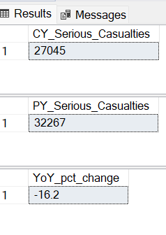

**-CY Accidents**

SELECT

COUNT(Accident_Index) as CY_Total_Accidents

FROM Road_Accident_Data

WHERE Accident_Yr = 2022

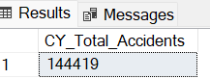

**-PY Accidents**

SELECT

COUNT(Accident_Index) as PY_Total_Accidents

FROM Road_Accident_Data

WHERE Accident_Yr = 2021

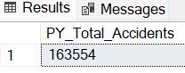

**-YoY Change**

SELECT

ROUND(

100 *(

CAST((SELECT COUNT(Accident_Index) FROM Road_Accident_Data WHERE Accident_Yr = 2022) AS FLOAT)-

CAST((SELECT COUNT(Accident_Index) FROM Road_Accident_Data WHERE Accident_Yr = 2021) AS FLOAT))/

CAST((SELECT COUNT(Accident_Index) FROM Road_Accident_Data WHERE Accident_Yr = 2021) AS FLOAT), 1) YoY_pct_change

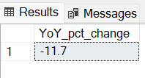

**2.SECONDARY KPI’S**

**-CY Casualties by Vehicle type**

SELECT

Vehicle_Type,

SUM(Number_of_Casualties)

FROM Road_Accident_Data

GROUP BY Vehicle_type

ALTER TABLE Road_Accident_Data

ADD Vehicle_type_group VARCHAR(20)

SELECT

Vehicle_Type,

(CASE

WHEN Vehicle_Type = 'Agricultural Vehicle' THEN 'Agriculture'

WHEN Vehicle_Type IN ('Car', 'Taxi/Private hire car') THEN 'Car'

WHEN Vehicle_Type IN ('Bus or coach (17 or more pass seats)', 'Minibus (8 - 16 passenger seats)') THEN 'Bus'

WHEN Vehicle_Type IN ('Goods over 3.5t. and under 7.5t', 'Goods 7.5 tonnes mgw and over', 'Van / Goods 3.5 tonnes mgw or under') THEN 'Van'

WHEN Vehicle_Type IN ('Motorcycle 50cc and under', 'Motorcycle over 500cc', 'Pedal cycle', 'Motorcycle over 125cc and up to 500cc', 'Motorcycle 125cc and under') THEN 'Bike'

ELSE 'Others'

END) AS Vehicle_type_grouping

FROM Road_Accident_Data

UPDATE Road_Accident_Data

SET Vehicle_type_group = (

(CASE

WHEN Vehicle_Type = 'Agricultural Vehicle' THEN 'Agriculture'

WHEN Vehicle_Type IN ('Car', 'Taxi/Private hire car') THEN 'Car'

WHEN Vehicle_Type IN ('Bus or coach (17 or more pass seats)', 'Minibus (8 - 16 passenger seats)') THEN 'Bus'

WHEN Vehicle_Type IN ('Goods over 3.5t. and under 7.5t', 'Goods 7.5 tonnes mgw and over', 'Van / Goods 3.5 tonnes mgw or under') THEN 'Van'

WHEN Vehicle_Type IN ('Motorcycle 50cc and under', 'Motorcycle over 500cc', 'Pedal cycle', 'Motorcycle over 125cc and up to 500cc', 'Motorcycle 125cc and under') THEN 'Bike'

ELSE 'Others'

END)

)

SELECT

Vehicle_type_group,

SUM(Number_of_Casualties) AS No_of_Casualties_by_vehicle_type

FROM Road_Accident_Data

WHERE Accident_Yr = 2022

GROUP BY Vehicle_type_group

ORDER BY 2 DESC

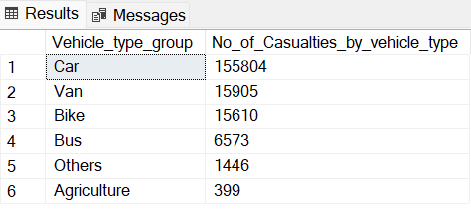

**POWER BI**

**-Monthly trend showing comparison of Casualties of CY and PY**

SELECT

Accident_Date,

DATENAME(MONTH, Accident_Date)

FROM Road_Accident_Data

ALTER TABLE Road_Accident_Data

ADD Month_Name VARCHAR(20)

UPDATE Road_Accident_Data

SET Month_Name = DATENAME(MONTH, Accident_Date)

SELECT

MONTH(Accident_Date) Month_Number,

Month_Name,

Accident_Yr,

SUM(Number_of_Casualties) AS Caualties_by_Month

FROM Road_Accident_Data

GROUP BY MONTH(Accident_Date),Accident_Yr,Month_Name

ORDER BY 3,1

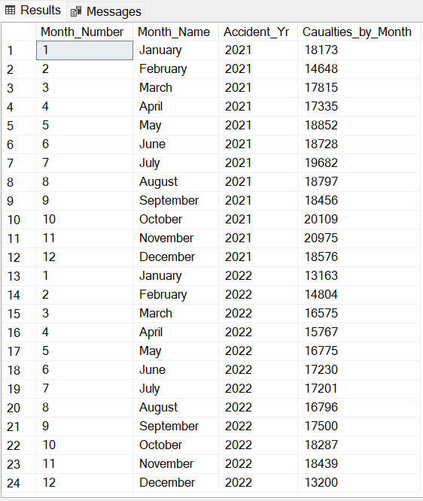

**-Casualties by Road type for CY**

SELECT

Road_Type,

SUM(Number_of_Casualties) as Casualties_by_Roadtype

FROM Road_Accident_Data

WHERE Accident_Yr = 2022

GROUP BY Road_Type

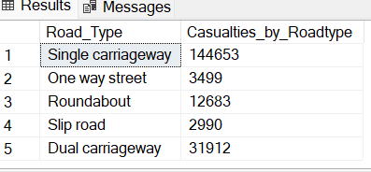

**-Casualties by Area**

SELECT

Urban_or_Rural_Area,

SUM(Number_of_Casualties) as Casualties_by_area

FROM Road_Accident_Data

WHERE Accident_Yr = 2022

GROUP BY Urban_or_Rural_Area

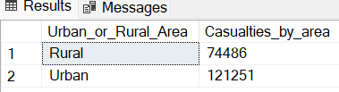

**-Casualties by Day/Night**

SELECT

Light_Conditions,

SUM(Number_of_Casualties) as Casualties_by_LightConditions

FROM Road_Accident_Data

WHERE Accident_Yr = 2022

GROUP BY Light_Conditions

